Tutorial

_______Circuit Registry
- Execute Clotho, and choose “circuit registry” from APPs


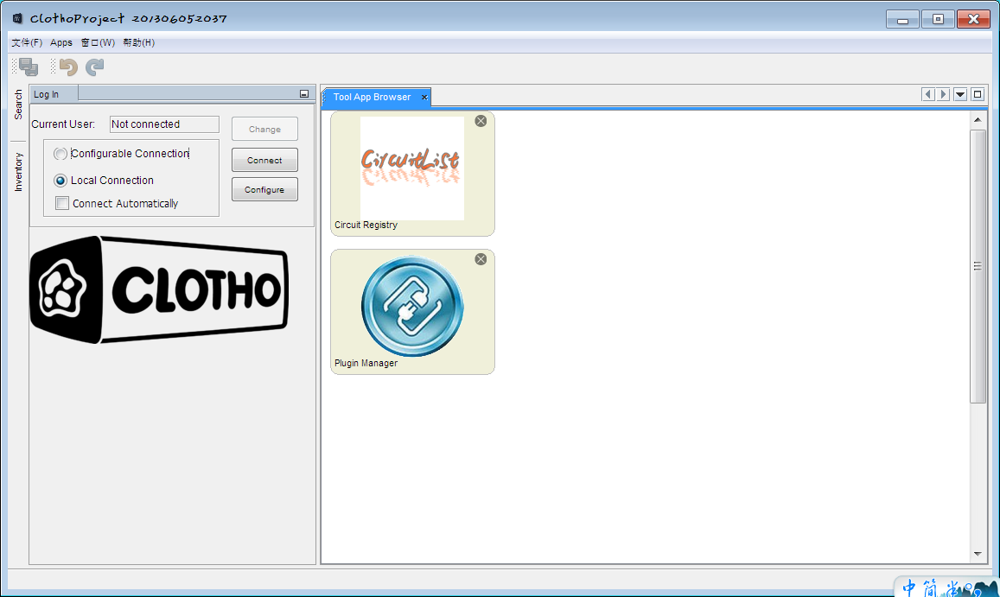

- Execute Circuit Registry, you can see our “Circuits List”

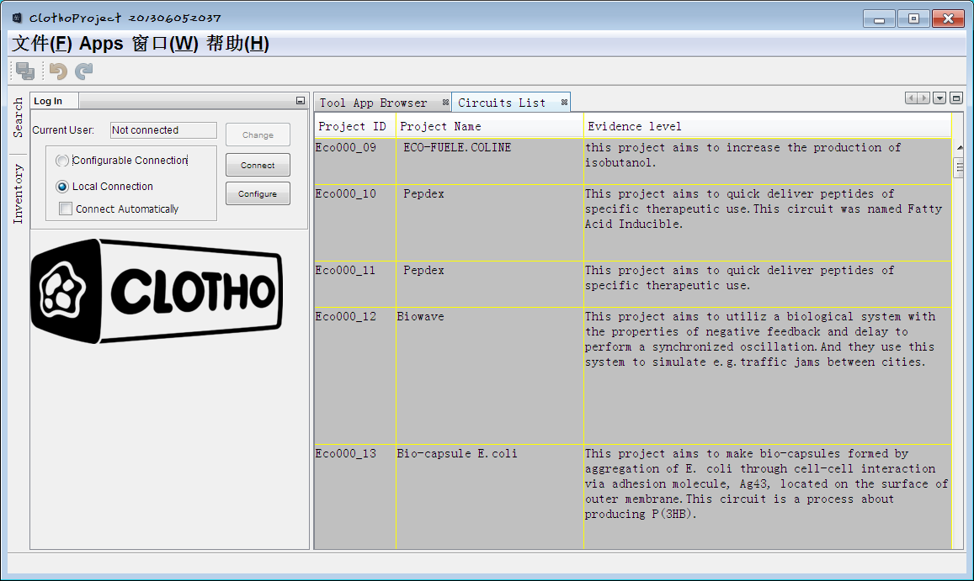

- Choose one Circuit that interest you, you can get further information about it by clicking anyplace of the row, where the Circuit in.

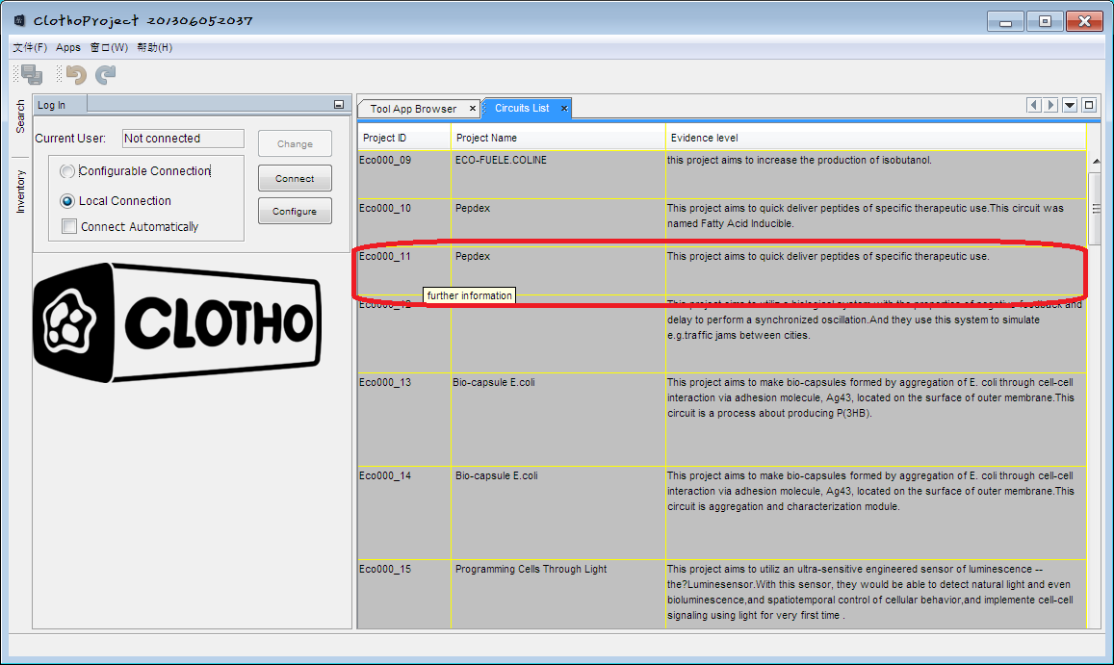

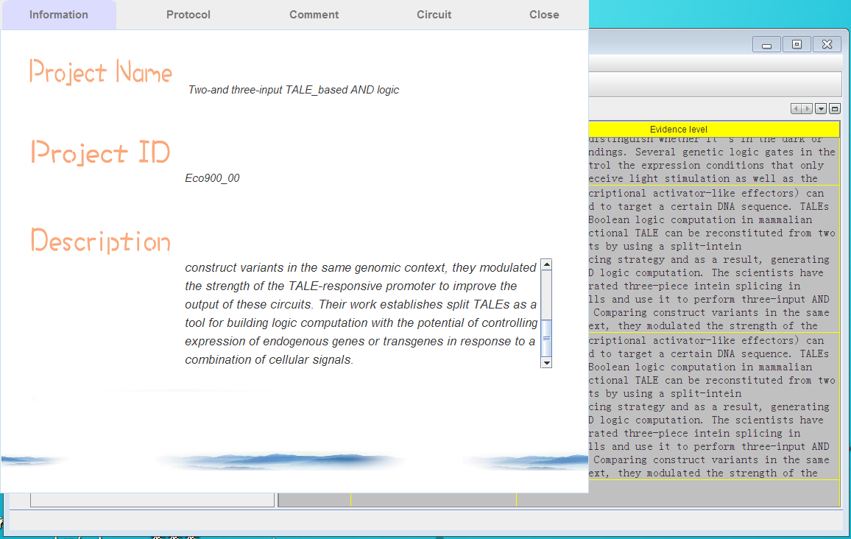

- Information ： general information about circuit

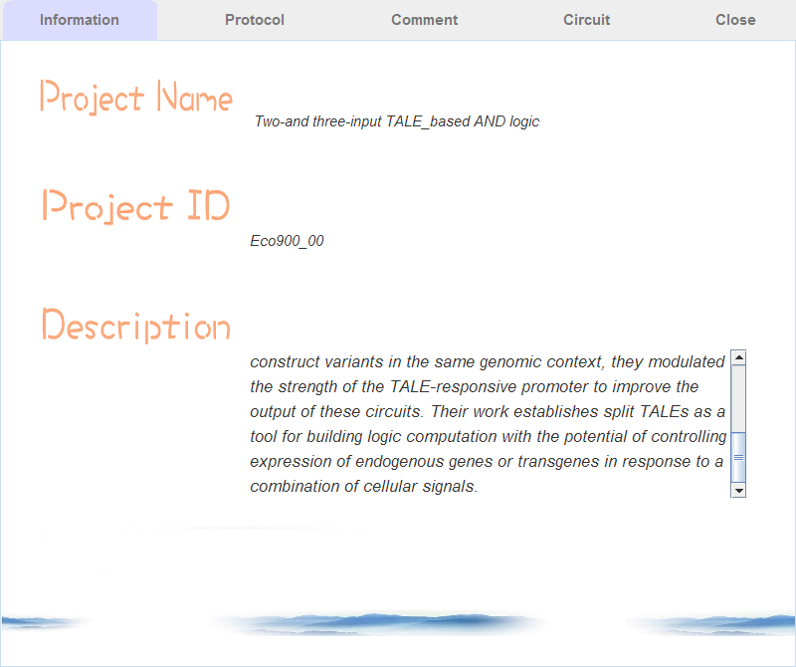

- Protocol: detail about how to build this circuit

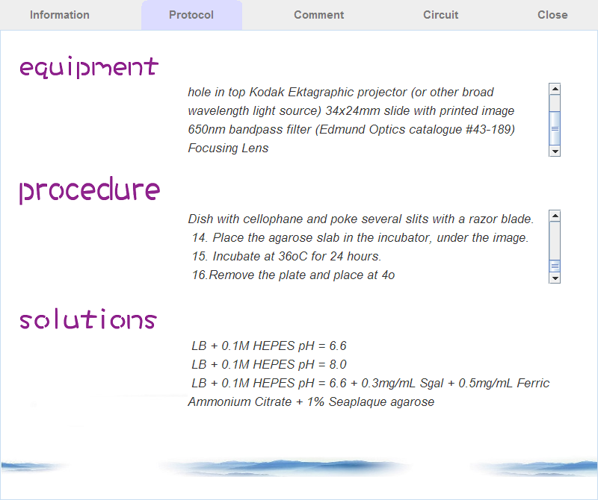

- Comment & CIrcuit will coming soon~

- Click Close to close further information window

